void bidirectionalSelectionSort(vector<int>& a)

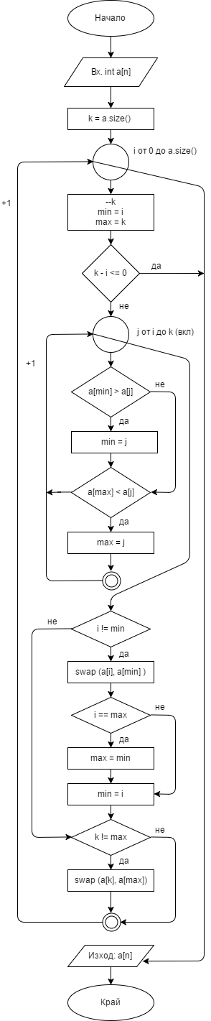

{

int k = a.size();

for (int i = 0; i < a.size(); ++i)

{

--k;

int min = i;

int max = k;

if (k - i <= 0) break;

//finding min and max positions

for (int j = i; j <= k; ++j)

{

if (a[min] > a[j]) min = j;

if (a[max] < a[j]) max = j;

}

if (i != min)

{

swap(a[i], a[min]);

if (i == max)

{

//because it got swapped for min

max = min;

}

min = i;

}

if (k != max)

{

swap(a[k], a[max]);

}

}

}

# С goto:

void bidirectionalSelectionSort(vector<int> arr) {

int N = arr.size();

int i = 0, j = 1;

label:

if (i < N)

{

int min = arr[i];

int index = i;

j = i + 1;

label2:

if (j < N)

{

if (arr[j] < min)

{

min = arr[j];

index = j;

}

j++;

goto label2;

}

else

{

int temp = arr[i];

arr[i] = min;

arr[index] = temp;

i++;

goto label;

}

}

}